A Free 30-min concert followed by Luncheon
Co-Hosted by PW & Bethlehem Lutheran
Contact: Sandy Bradford # 755-8525

7th Kalispell Art Walk Friday, 5:00-9:00pm
FPC hosts Student Art & Music from 12 Local Schools
Volunteer: Pastor Miriam # 212.0999

16th Children’s Christmas Service 10:00am Worship
Volunteer: Marilyn Anderson, WE Team # 871.0337

5:30 Candlelight Service

DAY TIME
Single Women’s Group
Monthly Events & Meals Around Town
Contacts: Sandy Manno # 309-2596
Pat Sanders # 257-1932

Sunday Singers
All Voices Welcome to Make a Joyful Noise to the Lord
Singing in Worship: 1st, 2nd and 4th Sundays with Practices those Sundays at 9:00am in the Chapel
Contact: Marilyn Anderson # 871-0337
Candee Stickney
Praise Team
Learns and Leads Worship Music Every 3rd Sunday
Practice 8:30am on 3rd Sunday – Instruments & Vocals
Contact: Doug Nelson # 756-7738
Children’s Sunday School During Worship
Ages 4-10 Study Worship Texts during Sermon
Kids Return with Lessons & Words for the Congregation
Co-Teach: Marilyn Anderson #871-0337

Adult Education Classes
October 14th 9:00-9:45am Fireside Rm
Intergenerational Class on Pastor Miriam’s Sabbatical: Exploring Scottish Presbyterianism
November 4th & 11th 9:00-9:50am Fireside Rm
Theories of Atonement with Steve Layman

Kerygma Study Wednesdays 11:30-1:00pm
34-Week Study on
Themes in the Bible Led by Pastor Glenn
Contact: Pastor Glenn # 249-7488

Building Homeless Day Center at Gateway Mall
Every Saturday 8:00am – Noon
Contact: Pastor Glenn # 249-7488

Men’s Group 1st Saturday of the Month
Breakfast w/ Speakers on Variety of Topics: All Welcome
8:30am at Scotty’s Restaurant on Hwy 93 near Murdochs
Contact: Dave Brewer # 261-5620

Boreas Small Group Monthly on 2nd Sunday
Meets following Worship for Fellowship & Mutual Support
Contact: Ann & Ralph Swain # 888-5399
Linda & Allen Pershall # 756-9649
Quilting Group
Beginners to Advanced
Quilting for Self & Community
1st Saturday/Monthly @ 10:00am
Contact: Noranne Yeager # 314-5286
A Matter of Balance: Managing Concerns About Falls
Class Begins: September 26th 1:30 – 3:30pm
This is a Six-Week FREE Class
Contact: Ann & Ralph Swain # 888-5399
Presbyterian Women
1st Thursday of the Month Luncheon & Speaker at Noon

PW Circles: Day-Time Circles Studying “God’s Promises”
Ruth Circle 3rd Thursday at 9:30am in Fireside Rm
Contact: Grace Buck # 892-4676
Sandy Bradford # 755-8525
Martha Circle 3rd Thursday at 1:30pm in Fireside Rm
Contact: Pat Sanders # 257.1932

Naomi Circle 3rd Thursday at 1:00pm in Parlor
Contact: Tammy Yonkers #755.2009

EVENING TIME
JuJu Volunteers
Every Other Month Dinners, Conversation & Training
Every Other Month: Tuesdays at JuJu @ 6:00pm
Contact: Pastor Miriam # 212-0999
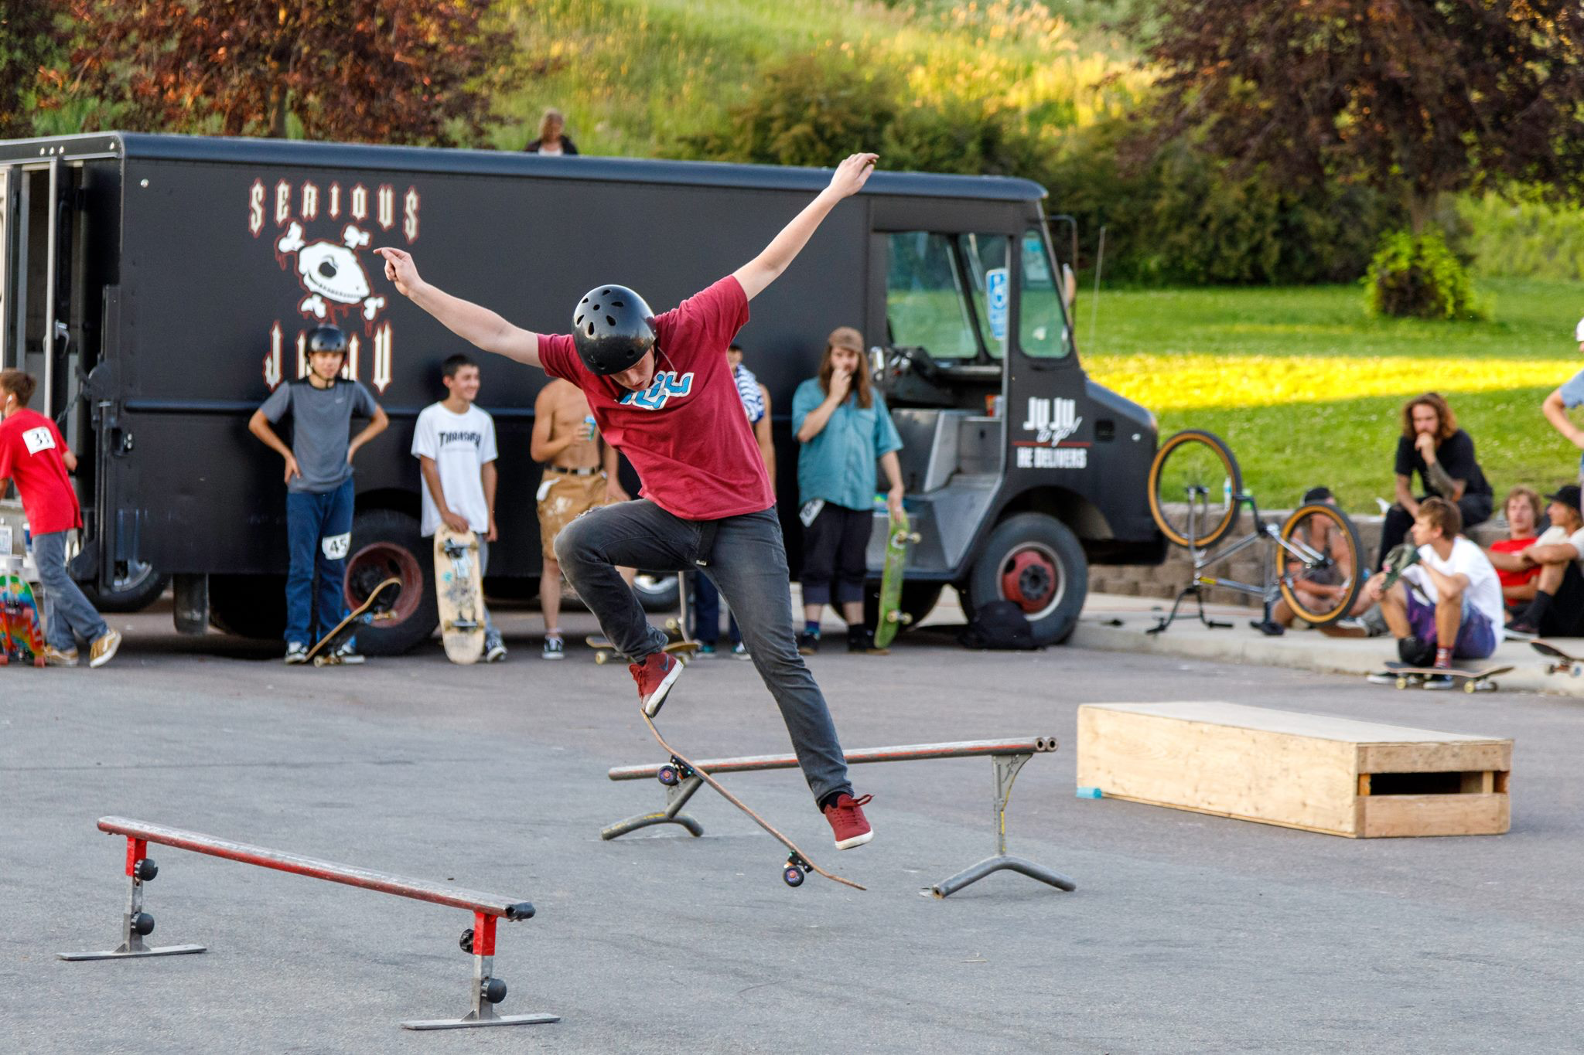
Tuesday After School Skate 4:00-6:00pm
At JuJu Warehouse – 707 West Center Street
Weekly Devotion on Prayers with Pizza
Volunteer: Pastor Miriam # 212-0999
Friday Skate Night at Serious JuJu
Open 52 Fridays a Year from 5:00-9:00pm
Skateboarding, Dinner, and Word - Volunteers Welcome
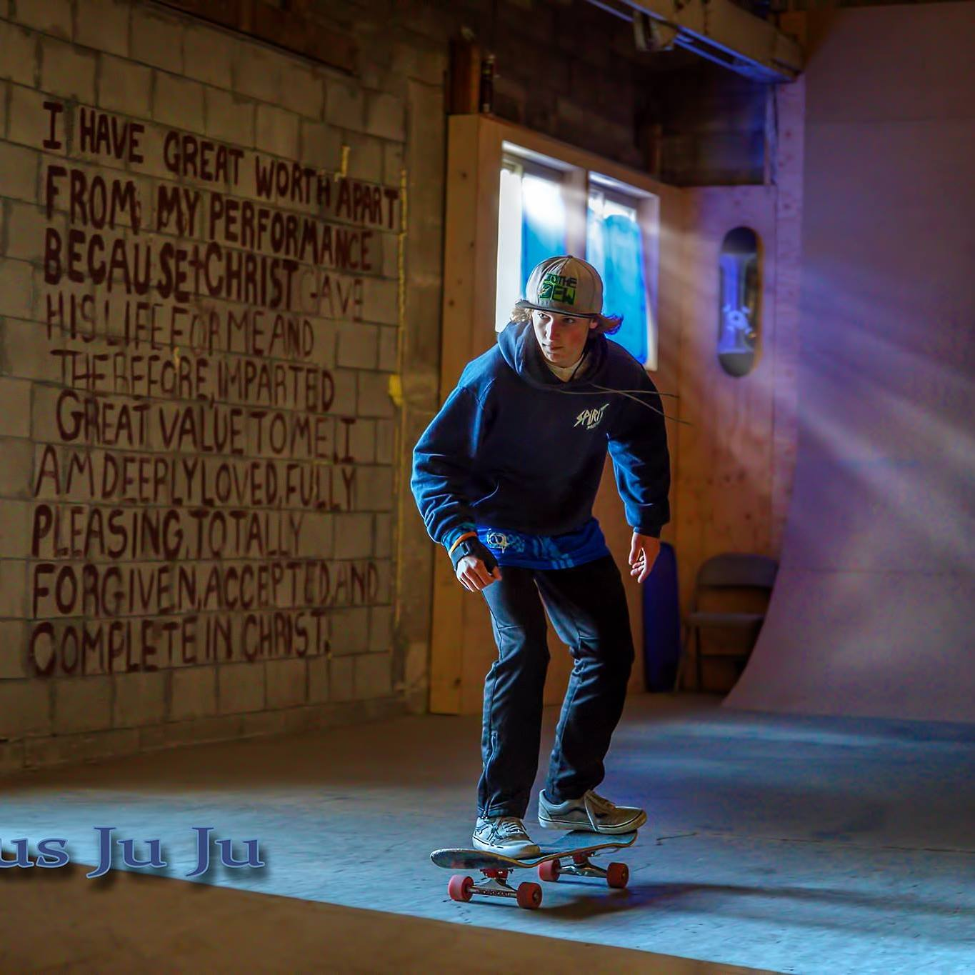
Contact: Pastor Miriam # 212-0999

Monday Adult Skate
During Winter Months from 6:00-8:00pm for those 18+
Devotion, Dinner, and Skateboarding
Contact: Tom Esch #250-5311

Eve Circle: Women’s Small Group
Reading “Grace” by Max Lucado See Monthly Calendar
Contact: Terri Siderius # 756-6312

Marriage Enrichment
Monthly Couple Dialogue & Support
Contacts: Diane & Jon Johnson # 862-9095
Russ Larson & Georgia Christianson # 275-0449

Sunday Night Cribbage Group
Weekly on Sunday Nights in Homes: Fall, Winter, Spring
3 Tables of 4 Players Each –
Subs needed at times.
Contact: Lee & Betsy Scifers # 755-2519

SMALL GROUPS of SERVICE at FPC
First Presbyterian Church of Kalispell
A MAIN Street Congregation
for the MAIN needs of our Community

www.fpckalispell.com
406.752.7488

Personnel Team
Focus on Support & Training for FPC Personnel
Monthly on Wednesdays @ 10:30am – Parlor
Contact: Tammy Yonkers # 755-2009

Music Ministry Task Force
Looking Ahead to Future of Music Ministry at FPC
Contact: Pastor Glenn # 249-7488

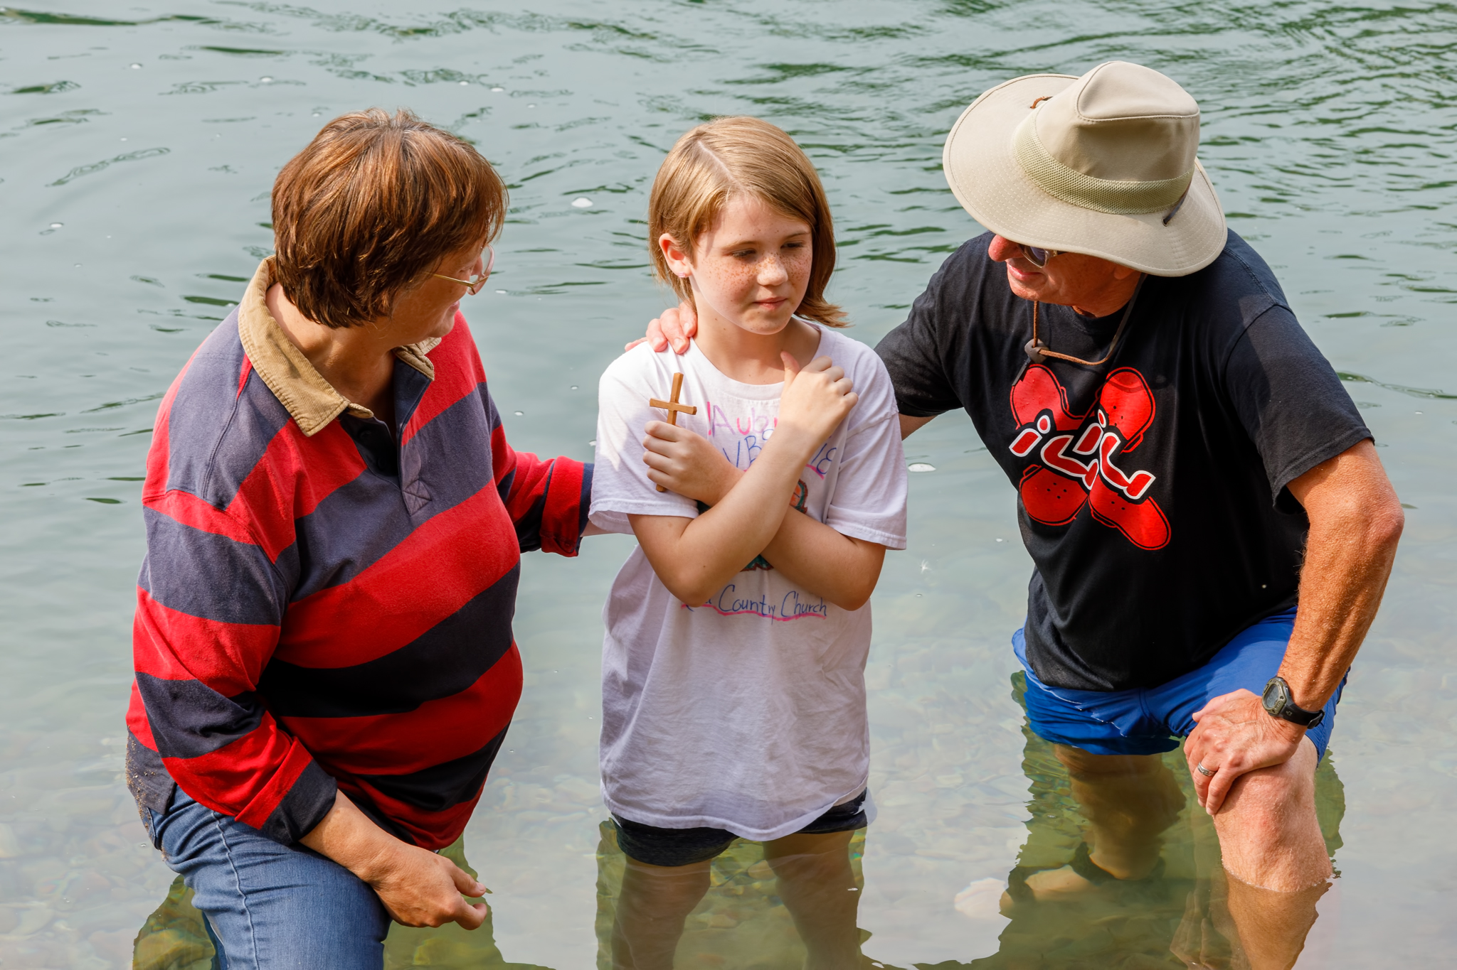
Session Teams
WE Team
Focus on Worship & Education for all Ages
2nd Wednesday/Monthly @ 9:30am – Parlor
Contact: Marilyn Anderson # 871-0337

Relational Team
Focus on Strengthening Relations: Church & Community
2nd Wednesday/Monthly @ 9:00am
Contact: Diane Johnson # 862-9095

Resource Team
Manage Resources of Church: Building, Budget, Personnel
2nd Thursday/Monthly @ 10:00am – Parlor
Contact: Roger Brewer # 257-0981
Allen Pershall # 756-9649
Deacon Teams
Guidance Team
Arrange Meetings, Inform Deacons of Prayer & Needs
Contact: Jon Johnson # 862-9095

Congregational Care Team
Weddings, Homebound, Hospital, Funerals, Cong Needs
Contact: Pat Sanders # 257-1932

Community Outreach Team
Helping Congregation Respond to Community Needs
Contact: Linda Pershall # 756-9649

Building Trusting Relationships
Built on Christ’s Main Cares
that Inspire the Heart for Action

Photo by Bob Paulus
Fall & Winter 2018
OCTOBER
20th PW Bazaar 9:30 - 2:00pm
Proceeds Go to Local Charities
Contact: Jeanne Olson # 755-3019

27-28th Presbytery Retreat at FPC Missoula
24-Hour Retreat with Adult & Children’s Ministry
Register: www.glacierpresbytery.org Cost: $25 w/meals

28th Community Halloween Carnival 5:00-7:00pm
FREE Community Event with Pizza Dinner & Games
Volunteer: Pastor Miriam # 212.0999

NOVEMBER
18th Thanksgiving Service & Thanksgiving Meal
Free Potluck Meal with Turkey & Potatoes Provided

DECEMBER
6th FHS Mini Choir Concert Noon in Sanctuary

